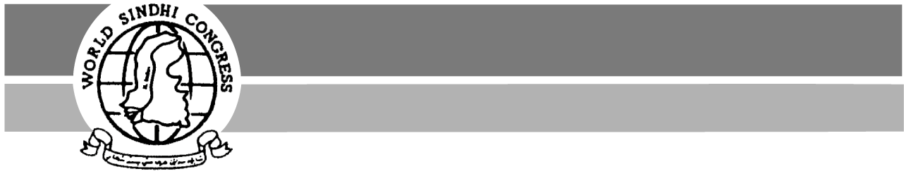
22 Newfields, Welwyn Garden City, Herts AL8 6YT, UK
Tel. +44 (0)1707 330437 ~ Fax +44 (0) 870-1226007

WORLD SINDHI CONGRESS®
world_sindhi_congress@yahoo.com
http://www.worldsindhicongress.org/

17418 Emelita St, Encino, CA 91316, USA
Tel. 1-818-917-6910 ~ Fax 1-408-715-0329

214 McGibbon Dr., Ottawa, ON K2L-3Y4 Canada
Tel 1-613-591-0451 ~ Fax 1-815-550-5694

Rt. Honourable Tony Blair
Prime Minster of Great Britain
10 Downing Street
London SW1 1AA

Subject: Extradition of Baloch human rights and democracy activists

Dear Sir,
On behalf of Baloch and Sindhi communities in the UK, we are writing to convey our deep concern and anxiety about recent reports that have appeared in the British media. On Wednesday 28 March 2007, the Guardian published a lead story reporting that British Government is negotiating with the Pakistani government for the extradition of a terrorist to be tried in the UK. It was also mentioned in the same report that British Government is considering a request from the Pakistani intelligence agency (ISI) to hand over eight Baloch human rights activists to Pakistan, including Mr. Mehran Baloch and Gazain Marri.
We do not understand why British Government and the representatives of the British people would consider negotiating the extradition of human rights activists to a military state known for exporting terrorism. This news was shocking for the Baloch and Sindhi communities in the UK, as they have traditional, historical and emotional relations with their oppressed brethren in Balochistan and Sindh.
We hope that it will not be a transgression of propriety to mention some relevant facts:
- Pakistan is run by its military and intelligence agencies and has an appalling human rights record. The Pakistani military has committed terrible atrocities against Baloch and Sindhi people. In last two years alone it is responsible for the killings of over 5,000 innocent Balochs, including women, children and the elderly; and the army and its intelligence agencies are responsible for the kidnapping, torture and extra-judicial killings of hundreds of Baloch and Sindhi political activists over the last few years.
- The Baloch and Sindhi people have been oppressed, subjugated and denied their fundamental human rights. Baloch and Sindhi demands for democratic and human rights have always been answered with ruthless military force by successive Pakistani governments.
- In last couple of years hundreds of Baloch and Sindhi human rights and democracy activists and leaders of political parties have been forcibly kidnapped by Pakistan’s intelligence agencies. Amnesty International, the Human Rights Commission of Pakistan, leaders of many political parties, the Chief Justice of the Supreme Court in Pakistan and numerous other national and international civil rights groups and NGOs have voiced their concerns about forced disappearances and inhumane torture and extra-judicial killings of political activists in Pakistan.
- The Baloch and Sindhi people are putting up a heroic resistance for the achievement of their basic human rights against a brutal, ruthless and fundamentalist army.
- General Musharaf has repeatedly discussed the physical elimination of Baloch nationalist leadership. On 26 August 2006, against the background of these declared aims, the Pakistani army killed 80-year-old Baloch nationalist leader Nawab Akbar Bugti.
- The aim to physically eliminate Baloch and Sindhi leadership is the Pakistani establishment’s method of resolving the Baloch and Sindhi national question in Pakistan. The reported efforts of the Pakistani government to extradite Baloch human rights activists in Europe are part of that establishment’s campaign to silence any voice in support of the people suffering in Balochistan and Sindh.
For the last several years, we have been trying to bring to your attention the brutalities of the Pakistani government against the Baloch and Sindhi people through various petitions. We sincerely believe that British government should side with the struggling democratic and secular forces in Balochistan and Sindh rather then with a brutal repressing and fundamentalist establishment headed by a rogue army, a known supporter of international terrorism and religious fundamentalism.
We believe that it is the obligation of British government, under its commitments to the UN and European charter of human rights, to exert pressure on the military regime in Pakistan for an immediate cessation of human rights violations in Balochistan and Sindh.
The oppressed nations in Pakistan are expecting the support of British people and government in their just struggle against the exploitative and ruthless military establishment of Pakistan.
On behalf of Baloch and Sindhi communities in the UK, we request British Government to raise the plight of Baloch and Sindhi People in international forums such as European Parliament and United Nations.

We look forward to hearing from you.
Dated:

World Sindhi Congress
22 Newfields
Welwyn Garden City,
Herts. AL8 6YT
http://www.worldsindhicongress.org/

Balochistan Action Committee (UK)

E-mail: balochactions@yahoo.co.uk

Baluchistan Rights Movement

Sindhi Baloch Forum

